Driver Control HW + BMS Project Meeting

8/17/2017

Sylvia, Frank

9:00 - 9:15 pm: Driver control design review - what needs to be changed?

Refer to the wiring diagram

Keep the topshell connector but the lights may not be controlled by Driver Control anymore(backup plan)

Other connectors to add?x

9:15 - 9:30 pm: Battery Box redesign

Mechanical is redesigning the battery box for cooling. They may need more space than the previous plan. Is there any way that we can reduce the space taken by boards?

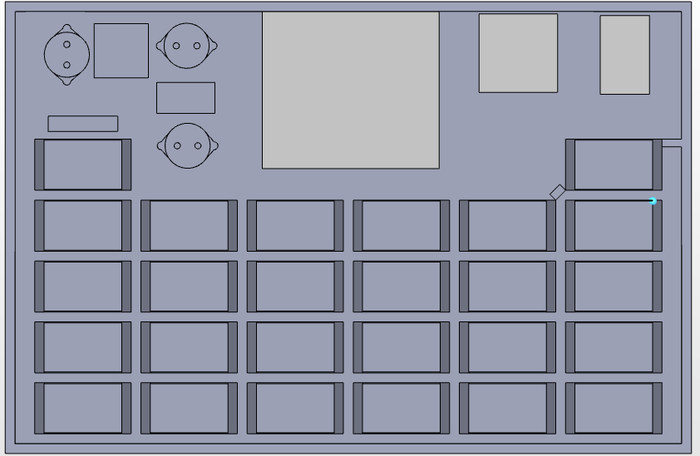

9:30 - 9:40 pm: Contactor discussion

How do you reconfigure the contactor circuitry to allow the array to be disconnected from the batteries automatically, as a possible future project for the team?

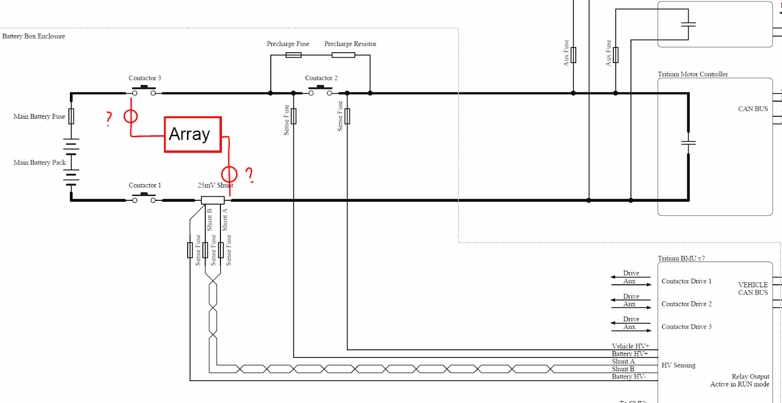

Three alternatives for over temperature: (Check regulation)

* Disconnect Array: pro: more power for hills, easy to implement con: consume power
* Powering only from array: pro: save power con: may not be enough power
* Optimal: Stop charging battery using array, Battery can still be connected to motor, power the car using both array and battery (ask Calsol)

9:40 - 9:50 pm: BMS discussion

Keep using Tritium but start researching for other BMS (Orion) as backup plan